
Self Service Banner

Handbook
on
Time Sheet and Leave Report Approval

OCCIDENTAL COLLEGE
Human Resources
2009

Employee Information Channel
The Employee Information channel is found in the myOxy portal (https://my.oxy.edu/) under the Employee Services Tab and it contains links to employee related information including time sheets and leave reports, benefits and deductions, pay information, tax forms, jobs summary and leave balances. Time approvers will use the time sheet and leave report links to review and approve time for Oxy employees and student workers.

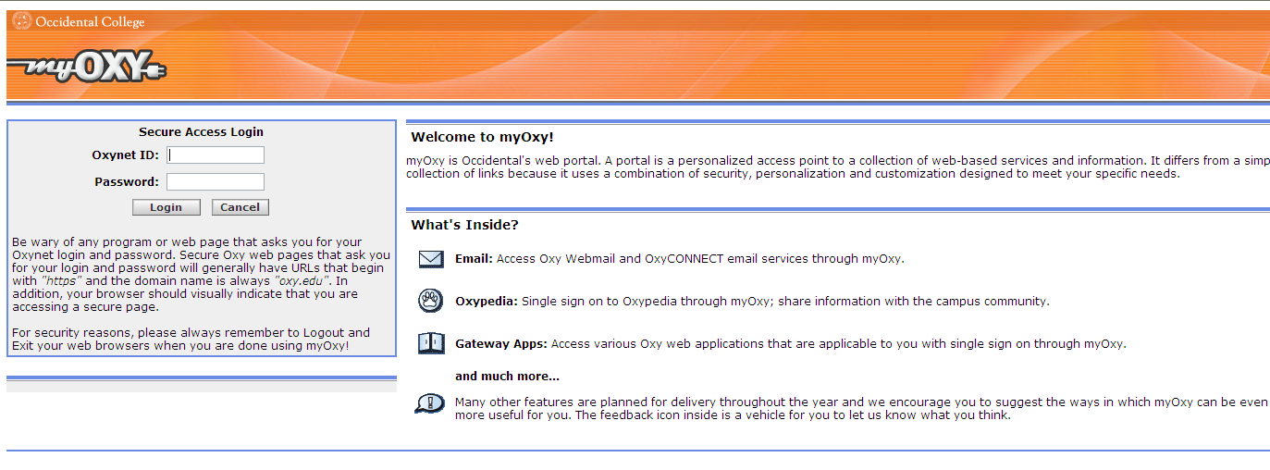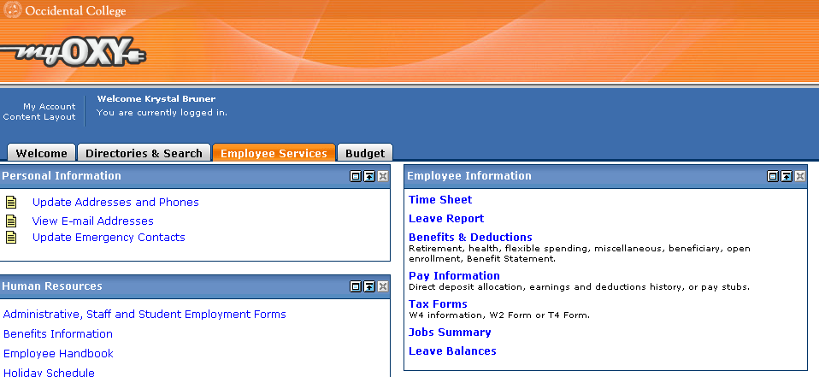

Time Sheet Approval for Direct Reports
Time sheets are for all hourly employees. Time Sheets should be submitted for the pay period with enough time that they are approved by noon of the Monday following the pay period end

Click on either the Time Sheet or Leave Report Link
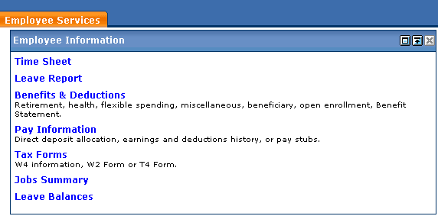

On the Time Reporting Selection screen: the Access my Time Sheet button will take the individual to their own time sheet; the Access my Leave Report button will take the individual to their own leave report; the Approve or Acknowledge Time button will take the individual to the time approval screens for the employees who report directly to them; the Act as Superuser button will allow a user with superuser rights to see employees who do not report to them directly (these individuals are typically back-up time approvers for other areas within their departments)

Click the Approve or Acknowledge Time button and click the Select button.
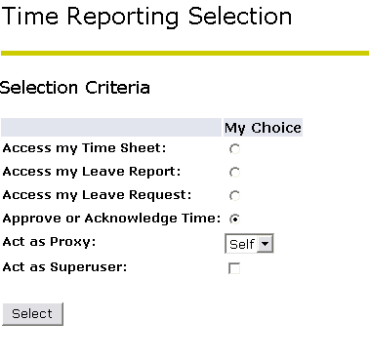

On the Approver Selection screen: the Time Sheet section will contain all hourly employees; the Leave Report section will contain all salaried employees; the Sort Order section allows the user to sort the employee records either first by status and then by name or simply by name
Click the My Choice button under Time Sheet and select the pay period from the drop-down menu

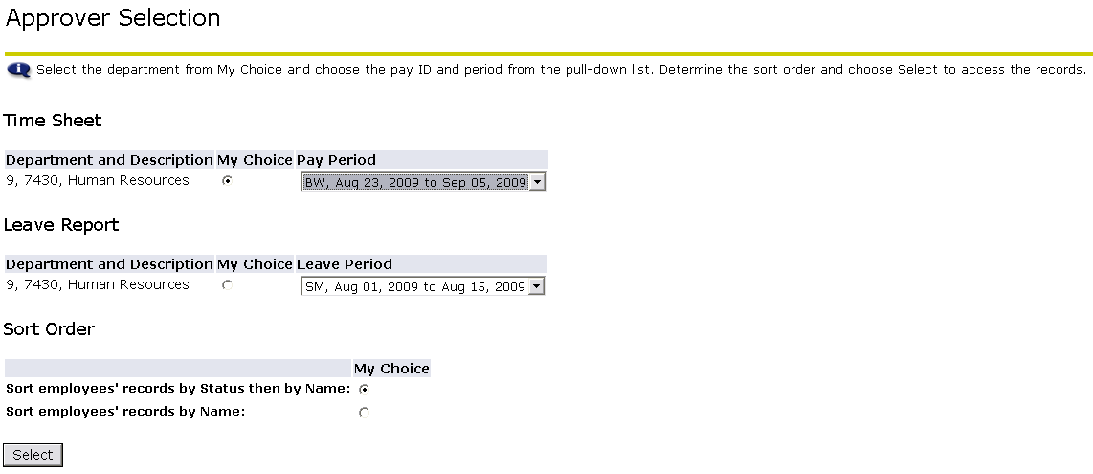

On the Department Summary screen: the employees will be sorted based on the selection made on the Approver Selection screen (in the example below the employees are sorted first by status and then by name); the Select New Department button will take the user back to the Approver Selection screen; the Select All, Approve or FYI button will approve the time for those employees where the Approve or FYI checkboxes are selected; the Reset button will remove any changes that have been made; the Save button will save any changes that have been made.
Under the Pending section, click on the Employee Name to review the time for that employee
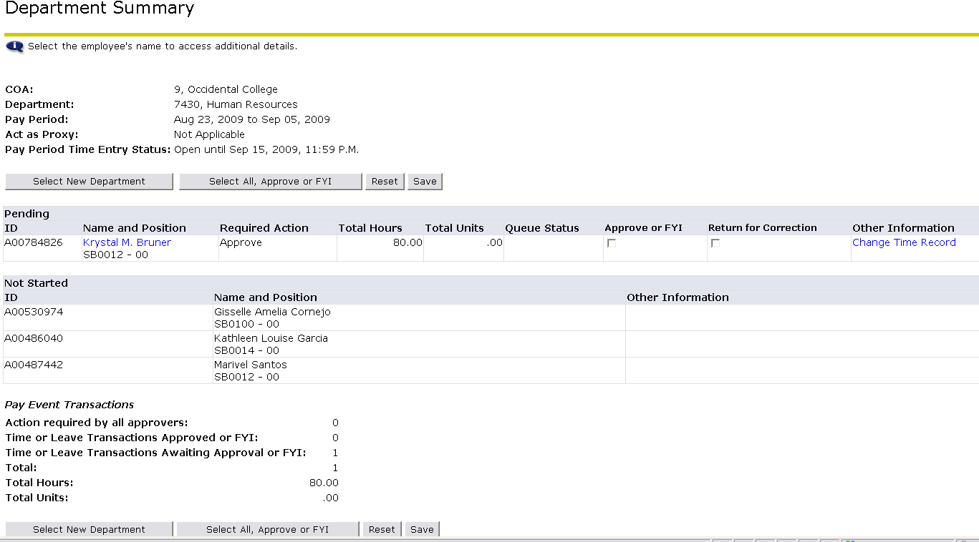

On the Employee Details screen: the Previous Menu button will take the user back to the Department Summary screen; the Approve button will approve the employee time and electronically forward it to payroll for processing; the Return for Correction button will return the time sheet back to the employee for corrections; the Change Record button will allow the time approver to make changes to the time that was submitted; the Delete button will delete the time transactions; the Add Comment button allows the time approver to add a comment to the time sheet; the Routing Queue links shows the routing of the time sheet; the Account Distribution link shows the FOAPAL information where the employee time will be charged
Review the hours as well as the time in and out information for the employee for accuracy.

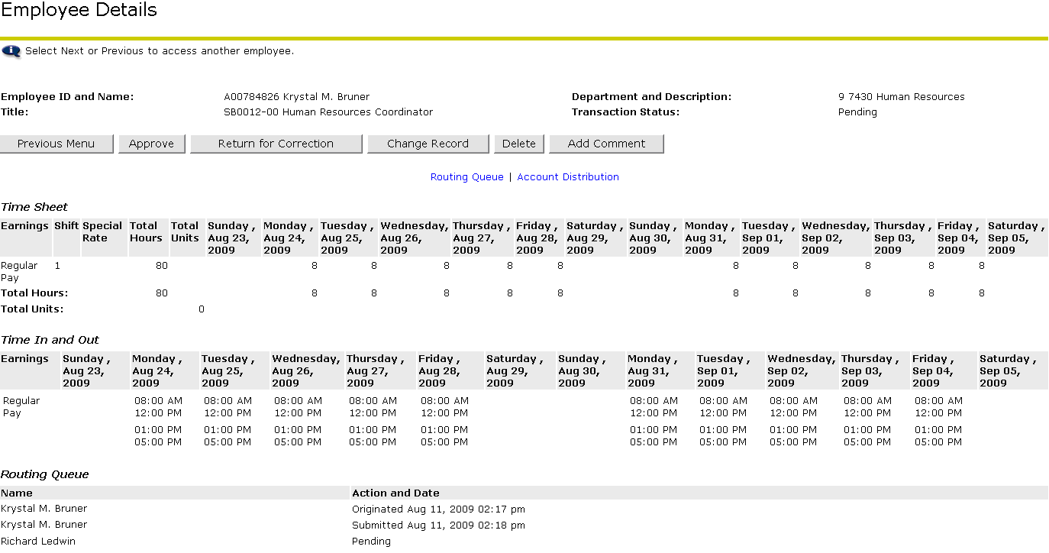
If the time sheet needs to be corrected, the time sheet can either be returned to the employee for correction or the time approver can make the necessary corrections.
To return the time sheet to the employee for correction, click the Return for Correction button (this will automatically return the time sheet to the employee for correction). Once this is done, communicate with the employee about the correction so that the employee can make the correction and resubmit for approval.
To make the correction for the employee, click the Change Record button. This button will open the Time Reporting screen where edits can be made to the time sheet. Once the time has been corrected, click the Previous Menu button to return to the Employee Details screen
To approve the time sheet, click the Approve button. This will automatically submit the time information to payroll for processing and the Routing Queue will be updated with the date and time of the approval.

Click the Previous Menu button to return to the Department Summary screen

Leave Report Approval for Direct Reports
Leave Reports are for all salaried employees. Leave Reports should be submitted for both pay periods of the month, within one week of the month end. If no vacation or sick leave time was taken for that month, both pay periods should be submitted for approval even though they will have zero hours. Please note usage of sick leave and vacation are reported in full day (8 hour) increments only.
Click on either the Time Sheet or Leave Report Link

On the Time Reporting Selection screen: the Access my Time Sheet button will take the individual to their own time sheet; the Access my Leave Report button will take the individual to their own leave report; the Approve or Acknowledge Time button will take the individual to the time approval screens for the employees who report directly to them; the Act as Superuser button will allow a user with superuser rights to see employees who do not report to them directly (these individuals are typically back-up time approvers for other areas within their departments)

Click the Approve or Acknowledge Time button and click the Select button.
On the Approver Selection screen: the Time Sheet section will contain all hourly employees; the Leave Report section will contain all salaried employees; the Sort Order section allows the user to sort the employee records either first by status and then by name or simply by name.
Click the My Choice button under Leave Report and select the pay period from the drop-down menu
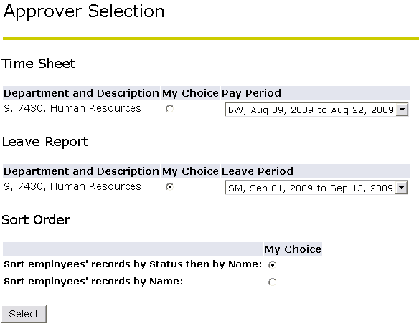

On the Department Summary screen: the employees will be sorted based on the selection made on the Approver Selection screen (in the example below the employees are sorted first by status and then by name); the Select New Department button will take the user back to the Approver Selection screen; the Select All, Approve or FYI button will approve the time for those employees where the Approve or FYI checkboxes are selected; the Reset button will remove any changes that have been made; the Save button will save any changes that have been made
Under the Pending section, click on the Employee Name to review the time for that employee

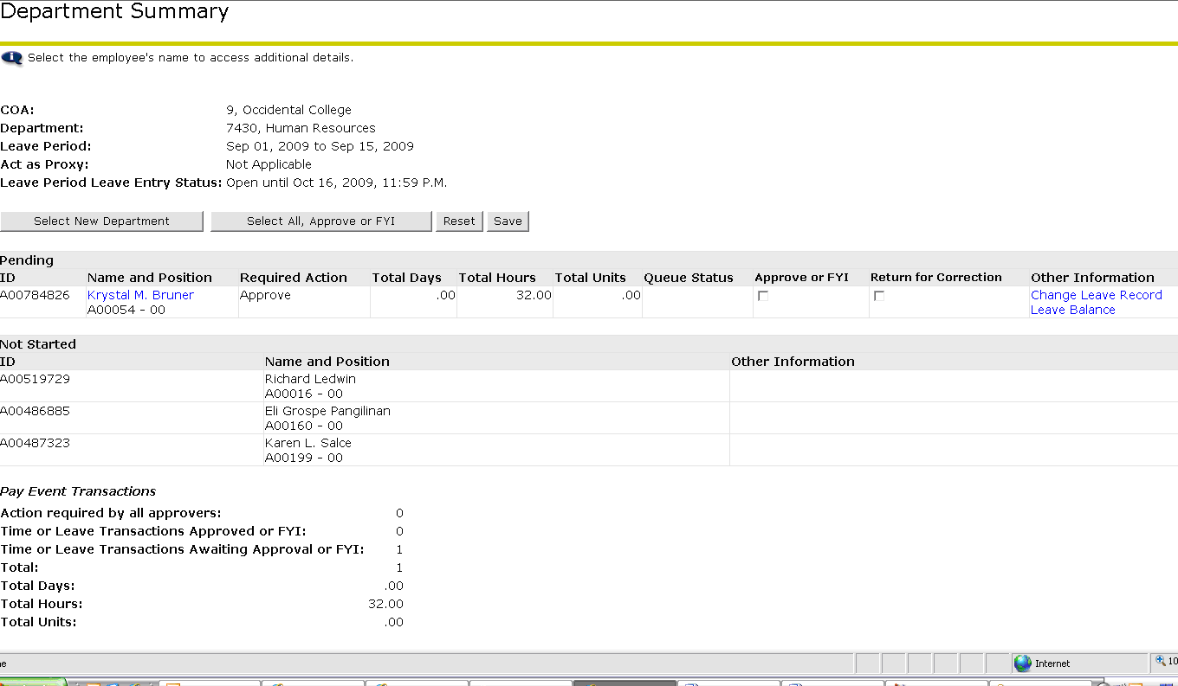

On the Employee Details screen: the Previous Menu button will take the user back to the Department Summary screen; the Approve button will approve the employee time and electronically forward it to payroll for processing; the Return for Correction button will return the leave report back to the employee for corrections; the Change Record button will allow the time approver to make changes to the time that was submitted; the Delete button will delete the time transactions; the Add Comment button allows the time approver to add a comment to the leave report; the Leave Balances link shows the leave balances for the employee; the Routing Queue link shows the routing of the leave report
Review the hour information for the employee for accuracy. Please note usage of sick leave and vacation are reported in full day (8 hour) increments only.

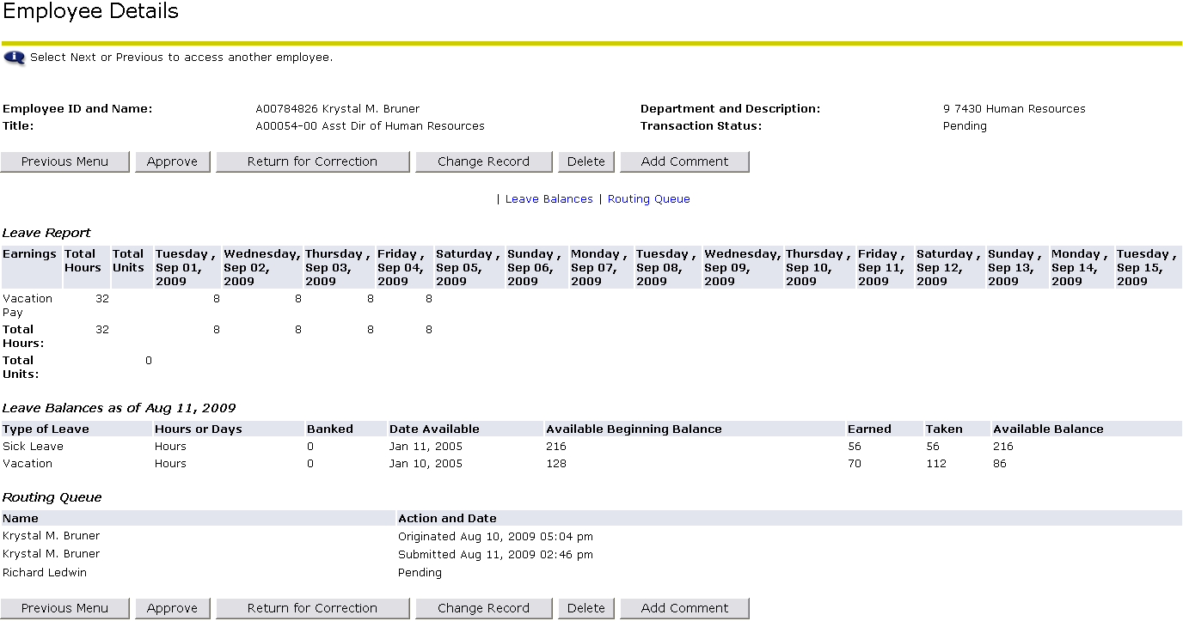

If the leave report needs to be corrected, the leave report can either be returned to the employee for correction or the time approver can make the necessary corrections.
To return the leave report to the employee for correction, click the Return for Correction button (this will automatically return the leave report to the employee for correction). Once this is done, communicate with the employee about the correction so that the employee can make the correction and resubmit for approval.
To make the correction for the employee, click the Change Record button. This button will open the Time Reporting screen where edits can be made to the leave report. Once the time has been corrected, click the Previous Menu button to return to the Employee Details screen
To approve the leave report, click the Approve button. This will automatically submit the time information to payroll for processing and the Routing Queue will be updated with the date and time of the approval.
Click the Previous Menu button to return to the Department Summary screen

To Act As A Superuser
Superusers are users who have been given special rights to see employees who do not report to them directly (these individuals are typically back-up time approvers for other areas within their departments). After the Approver Selection screen, all steps for time approval are the same.

Click on either the Time Sheet or Leave Report Link

Click the Approve or Acknowledge Time button and then click the Act as Superuser check box. Then click the Select button.
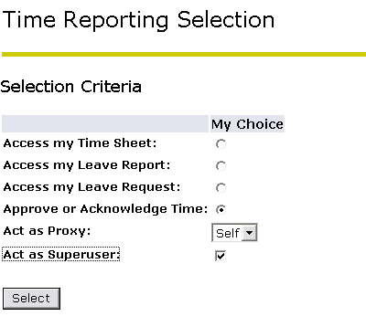

To Select Time Sheets (Hourly Employees)

On the Approver Selection screen:

Use the drop-down menu to select the Type of Records: Time Sheets
Use the drop-down menu to select the Pay ID: BW, Bi-weekly Hourly
Use the drop-down menu to select the Pay Number
Use the drop-down menu to select the Department

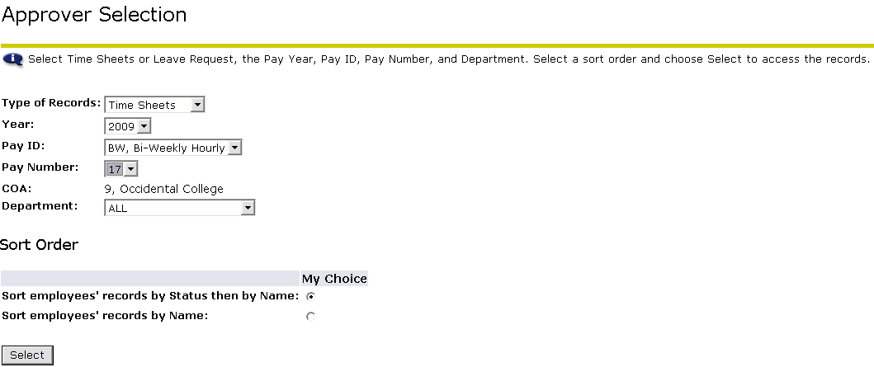

To Select Leave Reports (Salaried Employees)
On the Approver Selection screen:

Use the drop-down menu to select the Type of Records: Leave Report
Use the drop-down menu to select the Pay ID: SM, Semi-Monthly
Use the drop-down menu to select the Pay Number
Use the drop-down menu to select the Department



