Student Employment
Frequently Asked Questions
(Updated September 2021)

For student employment purposes, when does summer end and the fall semester begin?
Summer ends on August 21, 2021. The fall semester begins August 22, 2021. The academic year ends on May 14, 2022.

How do I place a request for a student worker?
To initiate a request, complete a Student Position Request Form and submit the form with a job description to studentemployment@oxy.edu with the following subject line: “Request for Student Worker”.

Do I have to submit a student position request form if I am rehiring the same student worker from last semester? YES.
A student position request form must be submitted for each academic year and for each summer session regardless of the length of the assignment or the funding source.

What is the maximum number of hours that students can work per week?
Students may hold more than one job and we recommend that they maintain a maximum 8 hours per week schedule to stay within their student earnings cap. As of July 1, 2020, we will be following the minimum wage requirements of $15.00 per hour per the city of Los Angeles. All earnings during the period of August 22, 2021 through May 14, 2022 will be applied towards a student’s earnings balance regardless of the funding source or length of assignment. This includes grants, stipends, endowments and resident advisors. Also, the earnings acquired during winter, spring and fall breaks would be applied to the student’s earnings balance.

Can students place a request to work more than 8 hours per week? YES.
Requests to work up to 8-hours per week must be submitted in writing by the student to the Dean of Students, the Director of Financial Aid, and the Employment Manager in the Human Resources Department for review and approval.

Are students allowed to work overtime? NO.
We do not recommend that your student work overtime hours. Overtime is incurred when an employee works more than 8 hours in a workday and 40 hours in a workweek.

How can I check the remaining earnings balance for my student worker?
Work award balance information can be obtained by contacting the Financial Aid Department at finaid@oxy.edu. All student workers and supervisors will be notified monthly via email of their student worker earnings balance.

How many units must a student be enrolled with Oxy in order to work on campus?
A minimum of 6 units.

Can students work for Oxy while participating in the Study Abroad Program? NO.

Frequently Asked Questions on EPAF’S

What is the EPAF System?
The EPAF (Electronic Personnel Action Form) channel is found in the myOxy portal (https://my.oxy.edu) under the Employee Services Tab. It is used for student on campus payroll records to hire, rehire, set up a wage rate or title change, and end a student’s work study assignment.

Am I set up to process EPAF’s?
You can find out if you have access by going through the following page. https://my.oxy.edu)

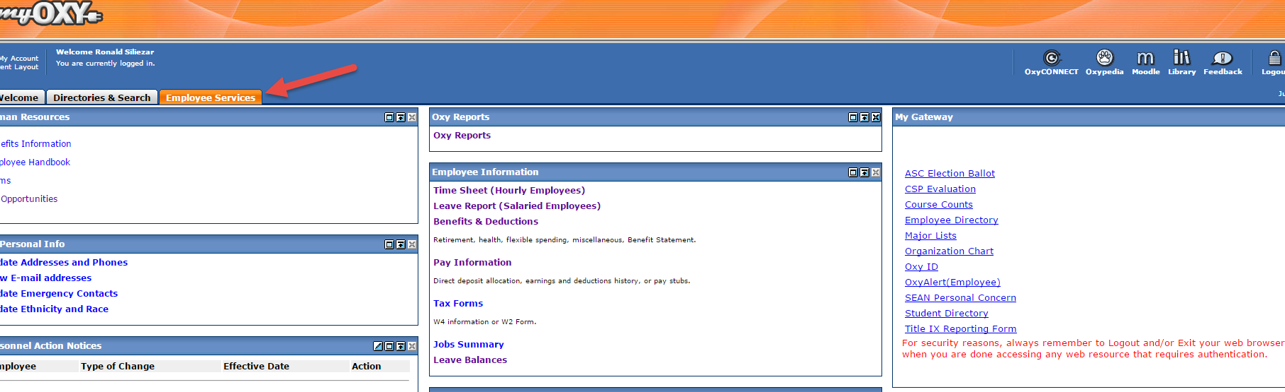
Toward mid-section of the page you should see the link “create New PAF”
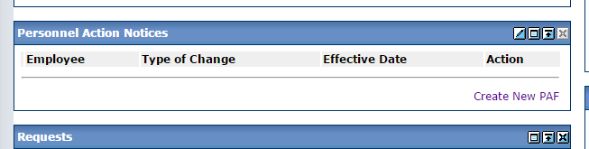
If you don’t see the link as indicated above, please contact Human Resources at studentemployment@oxy.edu.

What is the website to submit an EPAF?
https://my.oxy.edu

Do I need to complete any paperwork before submitting an EPAF?
If a student has not previously worked on campus, new hire paperwork must be completed in the Human Resources Department. If a student has worked before, then an EPAF is necessary to set up the job.

How do I submit an EPAF?
Please refer to video instructions below
http://screencast.com/t/20rGaVzMI8DN

I want to extend student assignments longer. Do I need to submit another EPAF? YES!
EPAF (Electronic Personnel Action Form) channel is found in the myOxy portal (https://my.oxy.edu) under the Employee Services Tab. It is used for student on campus payroll records to hire, rehire, set up a wage rate or title change, and end a student’s work study assignment.

My student worker cannot access his/her timesheet.
- Make sure to check if the steps below have been complete.
- Make certain the position request form has been approved by Human Resources.
- If the student has not previously worked on campus, new hire paperwork must be completed and on file with Human Resources.
- The EPAF has to be submitted in order for the job to be processed.
- If all items listed above have been completed and the timesheet is still inaccessible, contact Human Resources at studentemployment@oxy.edu for assistance.

Do I have a deadline to submit and EPAF?
- Make sure the EPAF is submitted BEFORE the start date of assignment.
- The Student will NOT be able to start work until the paperwork has been fully complete and an EPAF is submitted.

I receive an error message when rehiring my student worker through the EPAF.
When rehiring students into the same position number, always leave the JOB BEGIN DATE, CONTRACT TYPE and STEP fields blank.

I want to delete the record I created on the EPAF system.
Solution:
- Log into the EPAF channel (found in the myOxy portal under the EMPLOYEE SERVICES tab)
- Select the "Create New PAF" link
- Without entering data, select the "Originator Summary" link (found near the middle of your screen)
- Select the name of the student record that you will be deleting
- Select the "Delete" button (found in the upper left hand side of the screen
- Select the "Next" button to scroll to the next student record that you would like to delete
- After you have deleted all applicable records, you can select the “NEW EPAF” link to create a new EPAF record.

Can I terminate a student job via the EPAF system?
A student job can be terminated by performing the following steps:
- Click the CREATE NEW PAF link found in the Personnel Action Notices Channel.
- Type the current student workers Employee ID (A#) Note: The “A” in the employee ID# is case sensitive.
- Select the SWTRM2 form for approval category.
- Click on the grey “GO” button.
- Type in the last date of the pay period that you would like to end the assignment.
- Using the pull-down menu, list the reason for ending the assignment.
- Select the SAVE button.
- Select the SUBMIT button.

When terminating a student job via EPAF system I get an error.
Typically, this occurs when a job is ended for a pay period that has passed in which the student previously received payment.

I get the following Error message “this person is not defined as an employee”.
- If the student has never worked on campus, the student must complete new hire paperwork at the Human Resources Department.
- The Student will NOT be able to start work until the paperwork has been fully complete and an EPAF is submitted.

Note: Once you receive notification from Human Resources that the paperwork is complete, you will need to log into the EPAF channel, refresh the student’s record using the “UPDATE” button (located at the top, left-hand corner of the screen), select the SAVE button, and select the SUBMIT button to submit the record to Human Resources.

I am unable to see the EPAF link on 'my oxy'. How do I get it back?
The following video will help with this process.
http://screencast.com/t/3eWKFThuUFL7

How do I find out if an EPAF has been processed?
Once an EPAF is processed by HRIS an automated email is sent to the submitter the following morning. If an email is not received within 72 hours, please contact Human Resources.
What date should I use as the ‘Job Effective Date’ when completing an EPAF?
The date to be used is the beginning of the pay period. i.e. If the student works in the middle of the pay period, EPAF start date should be the beginning of the pay period. Please refer to the HOURLY payroll calendar and refer to the ‘Pay Period’ begin date.

My student is no longer working at my department. Do I need to submit an EPAF?
If a student does not work for your department, the job should be ended by using an EPAF. The form to use is SWTRM2 . This can be selected on dropdown on main EPAF selection form.

I am trying to rehire a student to work for my department and I am getting an error. What do I do?
IMPORTANT: If you are rehiring a student in your department, please do not enter a date on "JOB BEGIN DATE" field. By doing this, the EPAF will error.

Will the student worker receive a notification once EPAF has been processed?
Student is notified by an automated email of time sheet available once EPAF is processed.

