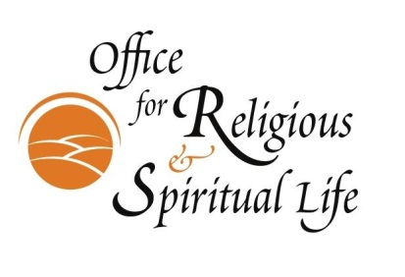
The 2023-2024 Values and Vocations Fellowship

The Values and Vocations Fellowship provides students the opportunity to explore the intersection of spirituality and social justice through community-based learning and a weekly integration seminar. The central premise of the Values and Vocations Fellowship is that social justice work cannot be effectively sustained over a lifetime without a strong, centered and regular spiritual practice.

The Values and Vocations Fellowship will be awarded to up to five Occidental students for the 2023-2024 academic year. Fellows will volunteer 8 to 10 hours per week on a social justice project at a community organization. An additional two hours each week will be spent attending a weekly integration seminar. During this seminar, fellows will engage in small group exercises, spiritual or contemplative practices and discussions about religion, spirituality, social justice, community engagement and vocation. Rev. Dr. Susan E. Young, Director for Religious and Spiritual Life, will lead the seminar. Fellows will receive a stipend of $1,000 per semester.

To apply for the Fellowship, students must: (1) submit the attached application; and (2) participate in a fifteen minute interview. The Values and Vocations Fellowship application is divided into two parts. Part one is the student application and part two is the faculty reference. Both the student application and faculty reference are due Tuesday, September 19, 2023. We will contact you to schedule an interview upon receiving your application.

Students can submit their application by emailing it to Rev. Dr. Young at young@oxy.edu. Faculty should complete the reference form attached to this document; faculty do not need to write a formal letter of reference. Faculty should submit their reference form to Rev. Dr. Young at young@oxy.edu.

Questions? Contact: The Rev. Dr. Susan E. Young at young@oxy.edu.

See next page for application.

2023-2024 Values and Vocations Fellowship

Part One: Student Application

Applications are due no later than September 19, 2023 to Rev. Dr. Susan Young at young@oxy.edu.

Name:

Address:

Email:

Phone:

Class/Year:

Major:

Student ID:

Name of faculty recommender:

Please provide answers to the following questions in no more than 3 single-spaced pages.

- Describe your interest in the Values and Vocations Fellowship. In particular, please discuss your spiritual journey or questions and how you believe the Fellowship will help you explore, develop or answer these questions.

- How do you think this Fellowship opportunity will help inform or shape your interest in social justice work or community based service?

- Describe a project you would like to pursue as a fellow. (Students are encouraged to develop their own project. ORSL can help students connect to community organizations if necessary.)

- How would you participate as a seminar member for this Fellowship? For example, how would you respond to your beliefs or values being challenged? How would you engage in discussion with people who differ from you?

- What would you like to leave this Fellowship knowing and having accomplished?

2023-2024 Values and Vocations Fellowship

Part Two: Faculty Recommendation Form

Date: Student Name:

Recommender Name: Dept.: _______________________

In what capacity do you know this student? Please check all that apply.

Academic advisor

Had the student in one class
Had the student in several classes

Worked on a prior project with the student
Other (specify)

1. Rate the student's academic abilities:
Weak Exceptional

1 2 3 4 5 6 7

2. Rate the student's ability to work independently:
Weak Exceptional

1 2 3 4 5 6 7

3. Rate the student's ability to engage in discussion:
Weak Exceptional

1 2 3 4 5 6 7

4. Rate the student’s ability to be challenged by views different from their own:
Weak Exceptional

1 2 3 4 5 6 7

5. Rate the student’s capacity for self-reflection:
Weak Exceptional

1 2 3 4 5 6 7

6. Please share any additional insights regarding this applicant’s suitability for this Fellowship.

Please email this form to Rev. Dr. Susan Young at young@oxy.edu by September 19, 2023.

